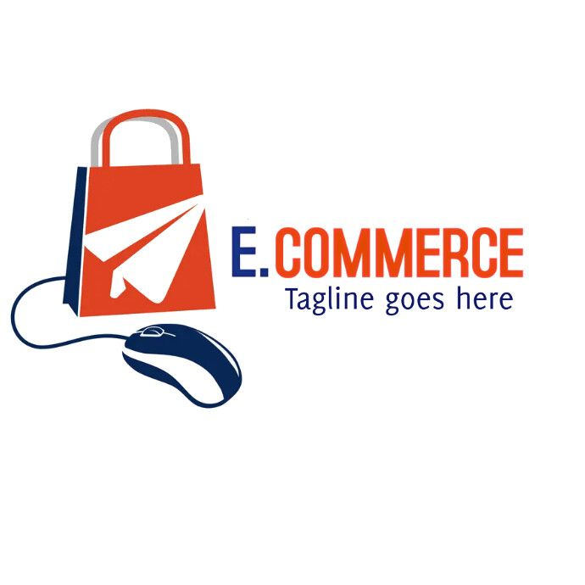

EbizChampions
Your Gateway to E-Commerce Mastery
Home Modules Resources Contact
Welcome to EbizChampions
This educational website is designed as part of our E-commerce course to explore digital business strategies, tools, and techniques. Dive into our modules to learn how to build, market, and manage an online business effectively.

Learning Modules

- Introduction to E-commerce
- Online Business Models
- Digital Marketing Basics
- Payment Systems & Online Security
- Setting Up an Online Store

Resources

Here you'll find helpful guides, external tools, and downloadable materials to support your learning journey.
- PDF: E-commerce Basics
- Video: Introduction to Digital Marketing
- Tool: Free Business Plan Generator

Contact

If you have any questions, feedback, or need support, feel free to reach out via email: info@ebizchampions.com
© 2025 EbizChampions | Educational Use Only

